Module Module1

Public adivina As Integer

End Module

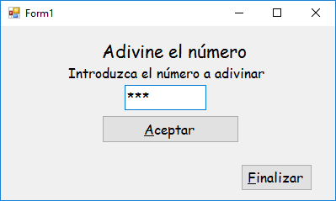

Public Class Form1

Private Sub btnFinalizar_Click(ByVal sender As System.Object, ByVal e As System.EventArgs) Handles btnFinalizar.Click

Me.Dispose()

End Sub

Private Sub txtAdivina_KeyPress(ByVal sender As Object, ByVal e As System.Windows.Forms.KeyPressEventArgs) Handles txtAdivina.KeyPress

If AscW(e.KeyChar) = Keys.Enter Then

btnAceptar.PerformClick()

Exit Sub

End If

If Not (e.KeyChar Like "[0-9]") And AscW(e.KeyChar) = Keys.Back Then

e.Handled = True

End If

End Sub

Private Sub btnAceptar_Click(ByVal sender As System.Object, ByVal e As System.EventArgs) Handles btnAceptar.Click

If IsNumeric(txtAdivina.Text) Then

adivina = txtAdivina.Text

Form2.ShowDialog()

Else

MessageBox.Show("Debe introducir un valor númerico", "AVISO")

End If

End Sub

End Class

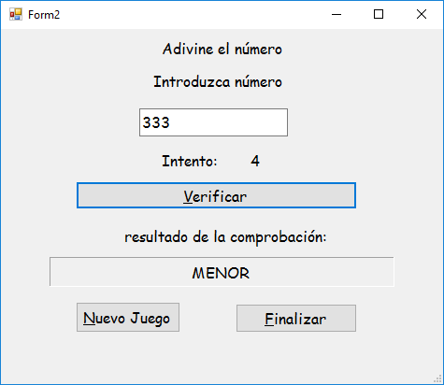

Public Class Form2

Private intentos As Integer = 1

Private Sub txtNumero_KeyPress(ByVal sender As Object, ByVal e As System.Windows.Forms.KeyPressEventArgs) Handles txtNumero.KeyPress

If AscW(e.KeyChar) = Keys.Enter Then

btnVerificar.PerformClick()

Exit Sub

End If

If Not (e.KeyChar Like "[0-9]") And AscW(e.KeyChar) = Keys.Back Then

e.Handled = True

End If

End Sub

Private Sub btnVerificar_Click(ByVal sender As System.Object, ByVal e As System.EventArgs) Handles btnVerificar.Click

If IsNumeric(txtNumero.Text) Then

Dim numero As Integer = txtNumero.Text

If adivina = numero Then

etResultado.Text = " ACERTADO en el intento " & intentos

txtNumero.Enabled = False

btnVerificar.Enabled = False

Exit Sub

End If

If adivina > numero Then

etResultado.Text = "MAYOR"

Else

etResultado.Text = "MENOR"

End If

intentos += 1

If intentos = 11 Then

etResultado.Text = "FALLASTE " & adivina

txtNumero.Enabled = False

btnVerificar.Enabled = False

Else

etIntento.Text = intentos

End If

Else

MessageBox.Show("Debe introducir un valor númerico", "AVISO")

End If

End Sub

Private Sub btnFinalizar_Click(ByVal sender As System.Object, ByVal e As System.EventArgs) Handles btnFinalizar.Click

End

End Sub

Private Sub btnNuevo_Click(ByVal sender As System.Object, ByVal e As System.EventArgs) Handles btnNuevo.Click

Me.Dispose()

End Sub

End Class